My NLU.py program is complete and running successfully with the accuracy of 93 percent

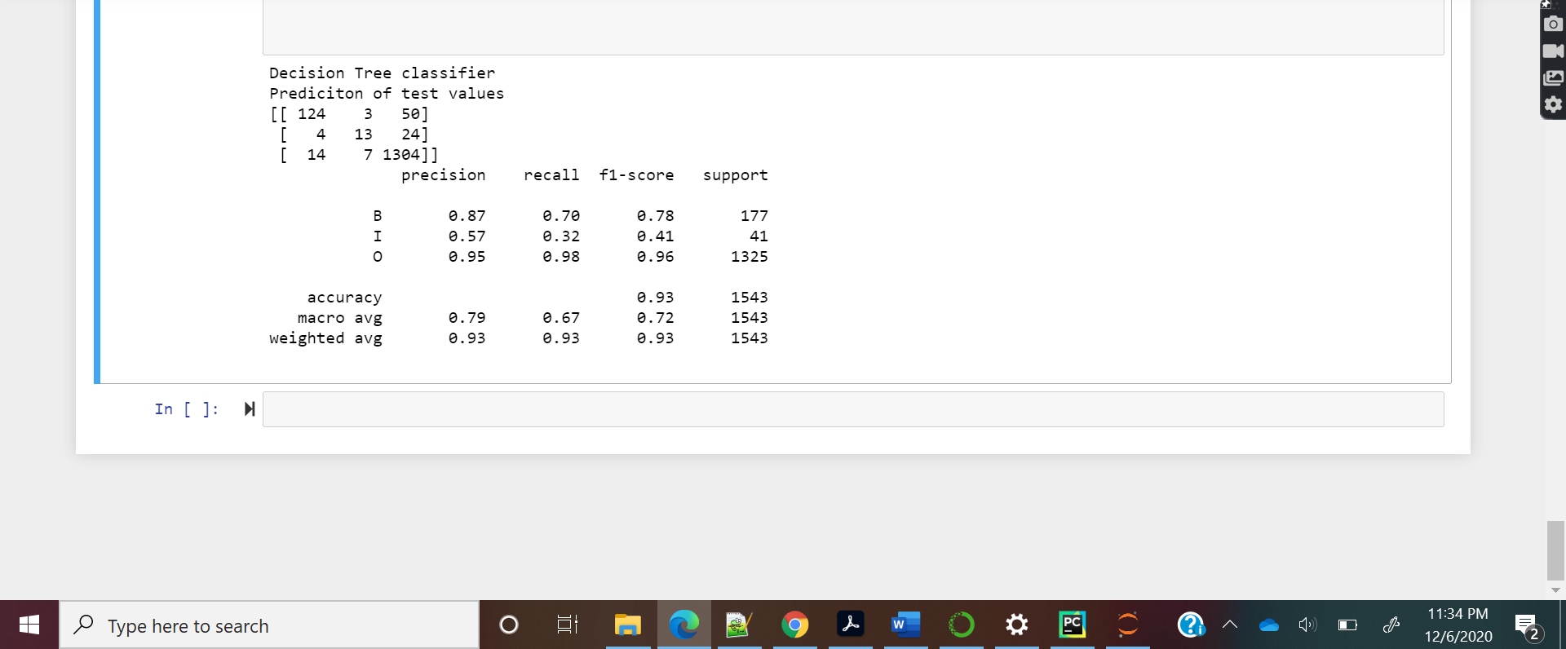

The additional three features are :

* If the word is lower.
* If the word is not capitalized.
* If has any special characters in it.